Hazael Guerrero

4 September 2023

**Module Two Lab**

1. **Connect to the database**you created and named in Module One (for example, Jetson). Type after the prompt mysql>  
   1. use (table you named);  
      1. Example: mysql> use Jetson;
2. **Create the Employee table**using the SQL statement shown here. Press **Return**after each line.

CREATE TABLE Employee (

Employee_ID SMALLINT,

First_Name VARCHAR(40),

Last_Name VARCHAR(60),

Department_ID SMALLINT,

Classification VARCHAR(10),

STATUS VARCHAR(10),

Salary DECIMAL(7,2));

1. **Create the Branches table.**Fill in the missing characters or punctuation in the incomplete statement shown below to complete this action.  
   1. CREATE Branches (

Department_ID SMALLINT,

Department_Name )

1. After creating the tables, use the correct commands to **describe them**. You’ll only be given commands to describe one of the tables and must complete the same action for the second one on your own. Validate your work with a screenshot.  
   1. describe Employee;
   2. Write the correct command to describe the Branches table

**( I accidently wrote Employee all in upper case letters)**

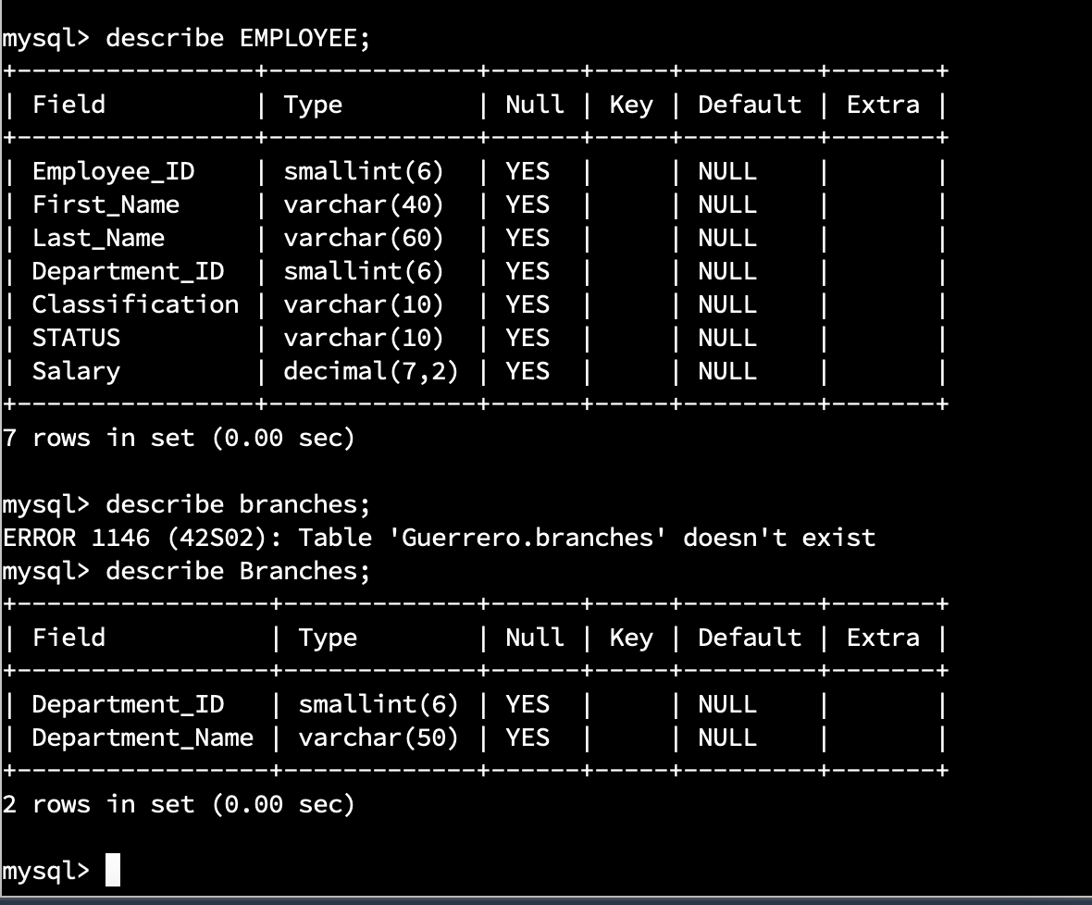

1. **Insert**the following **records into the Employee table (with support)**. Each line going from left to right is a record. Each line going from top to bottom is a column. Validate your work with a screenshot.  
   1. INSERT INTO Employee VALUES (100, 'John', 'Smith', 1, 'Exempt', 'Full-Time', 90000),   
      (101,'Mary','Jones',2,'Non-Exempt','Part-Time',35000),   
      (102,'Mary','Williams',3,'Exempt','Full-Time',80000);
   2. Type the command select* from Employee; and take a screenshot of it to validate this step.

1. **Insert**the following **records into the Employee table**for Gwen Johnson and Michael Jones by writing the correct SQL commands on your own **(without support).**  
   1. Gwen Johnson: Employee ID = 103, DEPARTMENT_ID = 4, Classification = NULL, Status = Full-Time, SALARY = 40000
   2. Michael Jones: Employee ID = 104, DEPARTMENT_ID = 4, Classification = Non-Exempt, Status = Full-Time, SALARY = 90000
   3. Insert your name into the table to verify and prove your work.
      1. (Your First and Last Name, or a nickname): Employee ID = 105, DEPARTMENT_ID = 1, Classification = Non-Exempt, Statues = Full-time, SALARY = (Choose a value between 50000 and 99000)
   4. Type the command select* from Employee; and take a screenshot of it to validate this step.

* 1. Insert records for a musician, athlete, or other famous character of your choice. Make sure to enter information for all of the fields listed in this table. The Department_ID must be a number between 1 and 4.
  2. Write the correct command to prove that you’ve successfully completed this step, and validate it with a screenshot.

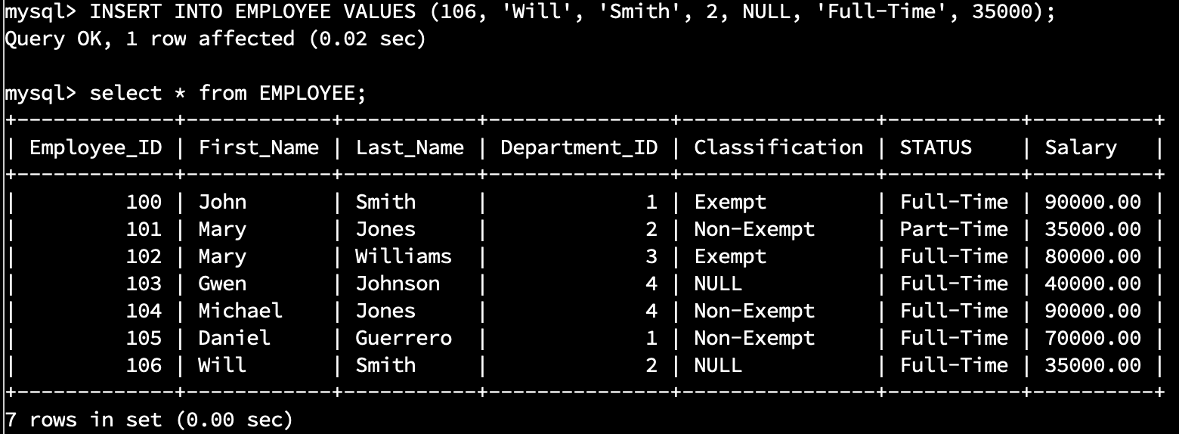

1. **Select the fields of last name, first name, and department id from the table.**Validate your work with a screenshot.

* 1. Select First_Name, Last_Name, Employee_ID, Department_ID from Employee;

